A
PROJECT SYNOPSIS
ON
“CAMPUS BUDDY”
FOR
IN PARTIAL FULFILLMENT OF
BACHELOR OF COMPUTER APPLICATION
IN

SHRI SAIBABA COLLEGE, SHIRDI
AFFILIATED TO

SUBMITTED BY:

- Darshan Nikam
Roll no: 18
- Tahir Khatik
Roll no: 10

BCA III SEM VI
2025 - 2026
UNDER THE GUIDANCE OF:
Prof. Deepak Bhawar

1.Introduction
Campus Buddy (AI assistant for college enquiry) : is a simple college inquiry system built using the Flask framework. It helps students get quick answers to common questions such as teacher details, department information, and college announcements. The system is available 24/7 and reduces the need to visit the college office.

2.Problem Statement
Students often waste time trying to find basic college information such as HOD contact details, faculty availability, or exam announcements. This information is usually spread across notice boards. Campus Buddy helps students by giving quick answers and reducing the need to visit the college office.

- Technical Stack
- Frontend: HTML, CSS, and JavaScript
- Backend: Python (Flask Framework)
- Database: Supabase (PostgreSQL)
- ORM: SQLAlchemy (convert database tables into Python classes)

4.System Architecture (Three-Layer Architecture)
- Presentation Layer: Simple chat interface where students type their questions
- Application Layer (Flask Logic): The "Brain" of the bot. It identifies the user's intent (Teacher Contact), searches for answers, and logs any questions it cannot answer.
- Data Layer (Supabase Memory): The central database where all college records (Teachers, FAQs, Announcements) and failed queries are securely stored.

5.Key Modules/ Features
- Query Search Module: The core engine that uses SQL ILIKE for case-insensitive matching. It ensures the bot understands queries regardless of capitalization (e.g., "HOD" vs "hod").
- Admin Security Module: A secure gateway that restricts database access. It allows only authorized administrators to safely add or update college records.
- Failed Query Logging: An analytics tool that saves unanswered questions. This helps admins identify information gaps and continuously improve the chatbot’s knowledge.

6.Future Scope
- Smarter Conversations: Use (NLP) to help the bot understand full sentences rather than just keywords.
- Admin Dashboard: Build a simple website so staff can update information without typing any code.

7.Minimum Requirements
- Operating System: Windows / Linux
- Processor: intel Core is or equivalent
- Ram: 4GB
- Storage: 1GB Free space
- Software Requirements:
    - Python 3.10
    - Web Browser (Chrome/Firefox)
    - Internet connection

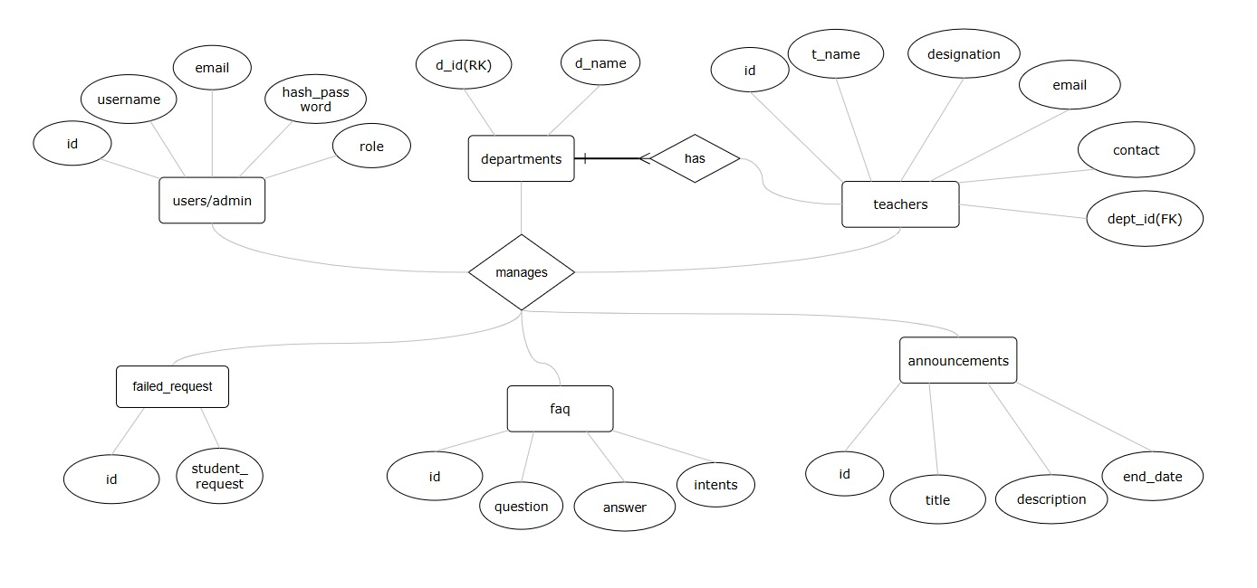
8.Entity-Relationship (ER) Diagram

